**Collections in Java**

A collection in java is a framework that provides architecture to store and manipulate the group of objects.

All the operations that you perform on a data such as searching, sorting, insertion, manipulation, deletion etc. can be performed by Java Collections.

Java Collection simply means a single unit of objects.

Java Collection framework provides many interfaces (Set, List, Queue, Deque etc.) and classes (ArrayList, Vector, LinkedList, PriorityQueue, HashSet, LinkedHashSet, TreeSet etc).

**Q. What is Collection in java**

Collection represents a single unit of objects i.e. a group.

**Q. What is framework in java**

(i) provides readymade architecture.

(ii) represents set of classes and interface.

(iii) is optional.

**Q. What is Collection framework**

Collection framework represents a unified architecture for storing and manipulating group of objects. It has:

Interfaces and its implementations i.e. classes

Algorithm

**Hierarchy of Collection Framework**

The java.util package contains all the classes and interfaces for Collection framework.

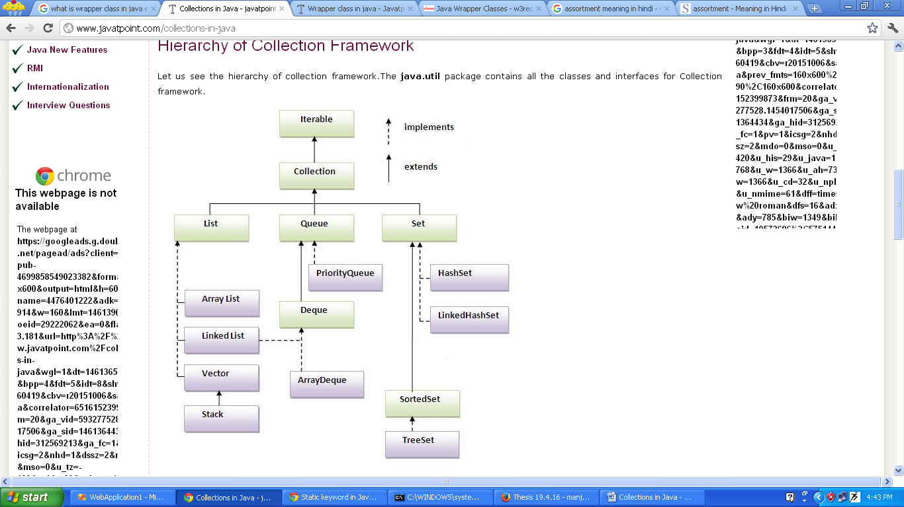

**Methods of Collection interface**

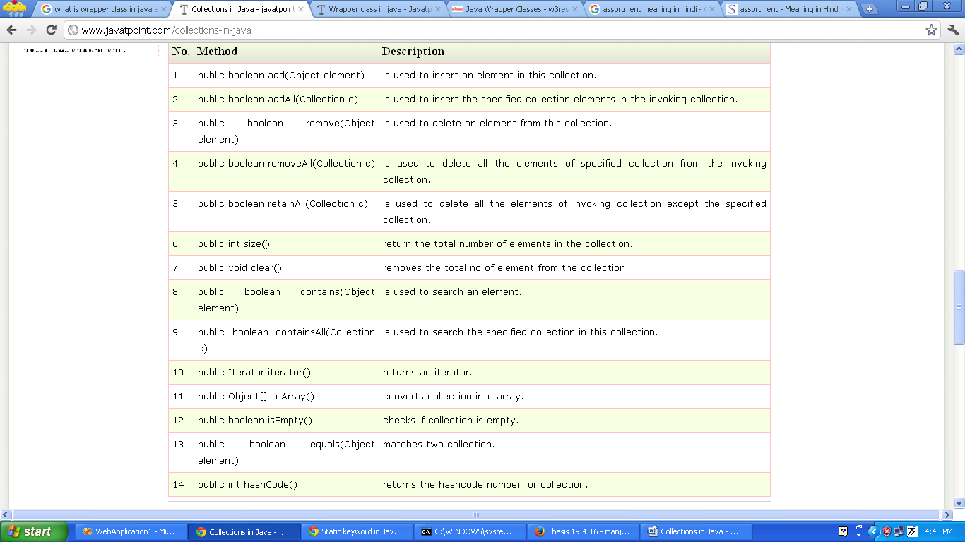There are many methods declared in the Collection interface. They are as follows:

**Iterator interface**

Iterator interface provides the facility of iterating the elements in forward direction only.

Methods of Iterator interface

There are only three methods in the Iterator interface. They are:

1. public boolean hasNext() : It returns true if iterator has more elements.
2. public object next() : It returns the element and moves the cursor pointer to the next element.
3. public void remove() : It removes the last elements returned by the iterator. It is rarely used.

**CLASS**

**I] ArrayList**

1. ArrayList class uses a dynamic array for storing the elements. It extends AbstractList class and implements List interface.
2. ArrayList class can contain duplicate elements.
3. ArrayList class maintains insertion order.
4. ArrayList class is non synchronized.
5. ArrayList allows random access because array works at the index basis.
6. In ArrayList class, manipulation is slow because a lot of shifting needs to be occurred if any element is removed from the array list.

**Java Non-generic Vs Generic Collection**

Java collection framework was non-generic before JDK 1.5. Since 1.5, it is generic.

Java new generic collection allows you to have only one type of object in collection. Now it is type safe so typecasting is not required at run time.

**Let's see the old non-generic example of creating java collection.**

ArrayList al=new ArrayList();//creating old non-generic arraylist

**Let's see the new generic example of creating java collection.**

ArrayList<String> al=new ArrayList<String>();//creating new generic arraylist

In generic collection, we specify the type in angular braces. Now ArrayList is forced to have only specified type of objects in it. If you try to add another type of object, it gives compile time error.

**Example of Java ArrayList class**

import java.util.*;

class demoArrayList{

public static void main(String args[]){

ArrayList<String> al=new ArrayList<String>();//creating arraylist

al.add("Santosh");//adding object in arraylist

al.add("Rajiv");

al.add("Pradeep");

al.add("Raju");

// retrieves element at 4th postion

String retval=a1.get(3);

System.out.println("Retrieved element is = " + retval);

Iterator itr=al.iterator();//getting Iterator from arraylist to traverse elements

while(itr.hasNext()){

System.out.println(itr.next());

}

}

}

Two ways to iterate the elements of collection in java

1. By Iterator interface.
2. By for-each loop.

In the above example, we have seen traversing ArrayList by Iterator. Let's see the example to traverse ArrayList elements using for-each loop.

import java.util.*;

class demoArrayList1{

public static void main(String args[]){

ArrayList<String> al=new ArrayList<String>();

al.add("Santosh");//adding object in arraylist

al.add("Rajiv");

al.add("Pradeep");

al.add("Raju");

for(String obj:al)

System.out.println(obj);

}

}

**User-defined class objects in Java ArrayList**

1. class Student{

int rollno;

String name;

int age;

Student(int rollno,String name,int age){

this.rollno=rollno;

this.name=name;

this.age=age; }}

1. import java.util.*;

public class TestCollection3{

public static void main(String args[]){

//Creating user-defined class objects

Student s1=new Student(101,"Sonoo",23);

Student s2=new Student(102,"Ravi",21);

Student s2=new Student(103,"Hanumat",25);

ArrayList<Student> al=new ArrayList<Student>();//creating arraylist

al.add(s1);//adding Student class object

al.add(s2);

al.add(s3);

Iterator itr=al.iterator();

//traversing elements of ArrayList object

while(itr.hasNext()){

Student st=(Student)itr.next();

System.out.println(st.rollno+" "+st.name+" "+st.age);

}

}

}

**Example of addAll(Collection c) method**

import java.util.*;

class TestCollection4{

public static void main(String args[]){

ArrayList<String> al=new ArrayList<String>();

al.add("Ravi");

al.add("Vijay");

al.add("Ajay");

ArrayList<String> al2=new ArrayList<String>();

al2.add("Sonoo");

al2.add("Hanumat");

al.addAll(al2);

Iterator itr=al.iterator();

while(itr.hasNext()){

System.out.println(itr.next());

}

} }

**Example of removeAll() method**

import java.util.*;

class TestCollection5{

public static void main(String args[]){

ArrayList<String> al=new ArrayList<String>();

al.add("Ravi");

al.add("Vijay");

al.add("Ajay");

ArrayList<String> al2=new ArrayList<String>();

al2.add("Ravi");

al2.add("Hanumat");

al.removeAll(al2);

System.out.println("iterating the elements after removing the elements of al2...");

Iterator itr=al.iterator();

while(itr.hasNext()){

System.out.println(itr.next());

} } }

O/P--iterating the elements after removing the elements of al2...

Vijay

Ajay

**Example of retainAll() method**

import java.util.*;

class TestCollection6{

public static void main(String args[]){

ArrayList<String> al=new ArrayList<String>();

al.add("Ravi");

al.add("Vijay");

al.add("Ajay");

ArrayList<String> al2=new ArrayList<String>();

al2.add("Ravi");

al2.add("Hanumat");

al.retainAll(al2);

System.out.println("iterating the elements after retaining the elements of al2...");

Iterator itr=al.iterator();

while(itr.hasNext()){

System.out.println(itr.next()); } }}

**II] LinkedList**

1. LinkedList class uses doubly linked list to store the elements. It extends the AbstractList class and implements List and Deque interfaces.
2. LinkedList class can contain duplicate elements.
3. LinkedList class maintains insertion order.
4. LinkedList class is non synchronized.
5. In Java LinkedList class, manipulation is fast because no shifting needs to be occurred.
6. LinkedList class can be used as list, stack or queue.

Eg:-

import java.util.*;

public class demoLinkedList{

public static void main(String args[]){

LinkedList<String> al=new LinkedList<String>();

al.add("Ravi");

al.add("Vijay");

al.add("Ravi");

al.add("Ajay");

Iterator itr=al.iterator();

while(itr.hasNext()){

System.out.println(itr.next());

}

}

}

**Difference between ArrayList and LinkedList**

ArrayList and LinkedList both implements List interface and maintains insertion order. Both are non synchronized classes.

**ArrayList**

1) ArrayList internally uses dynamic array to store the elements.

2) Manipulation with ArrayList is slow because it internally uses array. If any element is removed from the array, all the bits are shifted in memory.

3) ArrayList class can act as a list only because it implements List only.

4) ArrayList is better for storing and accessing data.

**LinkedList**

1. LinkedList internally uses doubly linked list to store the elements.
2. Manipulation with LinkedList is faster than ArrayList because it uses doubly linked list so no bit shifting is required in memory.
3. LinkedList class can act as a list and queue both because it implements List and Deque interfaces.
4. LinkedList is better for manipulating data.

Example of ArrayList and LinkedList in Java

import java.util.*;

class demoArrayLinked{

public static void main(String args[]){

List<String> al=new ArrayList<String>();//creating arraylist

al.add("Mohit");//adding object in arraylist

al.add("kuldeep");

al.add("Rubi");

al.add("Ajay");

List<String> al2=new LinkedList<String>();//creating linkedlist

al2.add("sudesh");//adding object in linkedlist

al2.add("manty");

al2.add("Swati");

al2.add("Juhi");

System.out.println("arraylist: "+al);

System.out.println("linkedlist: "+al2);

}

}

O/P: arraylist: [Mohit, kuldeep, Rubi,Ajay]

linkedlist: [sudesh, manty,Swati, Juhi]

**Java ListIterator Interface**

ListIterator Interface is used to traverse the element in backward and forward direction.

**Commonly used methods of ListIterator Interface:**

1. public boolean hasNext();
2. public Object next();
3. public boolean hasPrevious();
4. public Object previous();

import java.util.*;

public class demoLI{

public static void main(String args[]){

ArrayList<String> al=new ArrayList<String>();

al.add("Amit");

al.add("Vijay");

al.add("Kumar");

al.add(1,"Sachin");

ListIterator itr=al.listIterator();

System.out.println("traversing elements in forward direction...");

while(itr.hasNext()){

System.out.println(itr.next());

}

System.out.println("traversing elements in backward direction...");

while(itr.hasPrevious()){

System.out.println(itr.previous());

}

}

}

**Java HashSet**

Hashtable to store the elements. It extends AbstractSet class and implements Set interface.

It contains unique elements only.

**Difference between List and Set:**

List can contain duplicate elements whereas Set contains unique elements only.

import java.util.*;

class demoHashSet{

public static void main(String args[]){

HashSet<String> al=new HashSet<String>();

al.add("Ravi");

al.add("Vijay");

al.add("Ravi");

al.add("Ajay");

Iterator itr=al.iterator();

while(itr.hasNext()){

System.out.println(itr.next());

}

}

}

**LinkedHashSet**

It contains unique elements only like HashSet. It extends HashSet class and implements Set interface. It maintains insertion order.

import java.util.*;

class TestCollection10{

public static void main(String args[]){

LinkedHashSet<String> al=new LinkedHashSet<String>();

al.add("Ravi");

al.add("Vijay");

al.add("Ravi");

al.add("Ajay");

Iterator<String> itr=al.iterator();

while(itr.hasNext()){

System.out.println(itr.next());

}

}

}

**TreeSet**

It contains unique elements only like HashSet. The TreeSet class implements NavigableSet interface that extends the SortedSet interface. It maintains ascending order.

import java.util.*;

class TestCollection11{

public static void main(String args[]){

TreeSet<String> al=new TreeSet<String>();

al.add("Ravi");

al.add("Vijay");

al.add("Ravi");

al.add("Ajay");

Iterator<String> itr=al.iterator();

while(itr.hasNext()){

System.out.println(itr.next());

}

}

}

Output:Ajay

Ravi

Vijay

**Map Collection**

Map is not a true collection, its characteristics and behaviors are different than the other collections like List or Set. A map contains values on the basis of key i.e. key and value pair. Each key and value pair is known as an entry. Map contains only unique keys.

Map is useful if you have to search, update or delete elements on the basis of key.

**Why and When Use Maps:**

Maps are perfectly for key-value association mapping such as dictionaries. Use Maps when you want to retrieve and update elements by keys, or perform lookups by keys. Some examples:

* A map of error codes and their descriptions.
* A map of zip codes and cities.
* A map of managers and employees. Each manager (key) is associated with a list of employees (value) he manages.
* A map of classes and students. Each class (key) is associated with a list of students (value).

**Useful methods of Map interface**

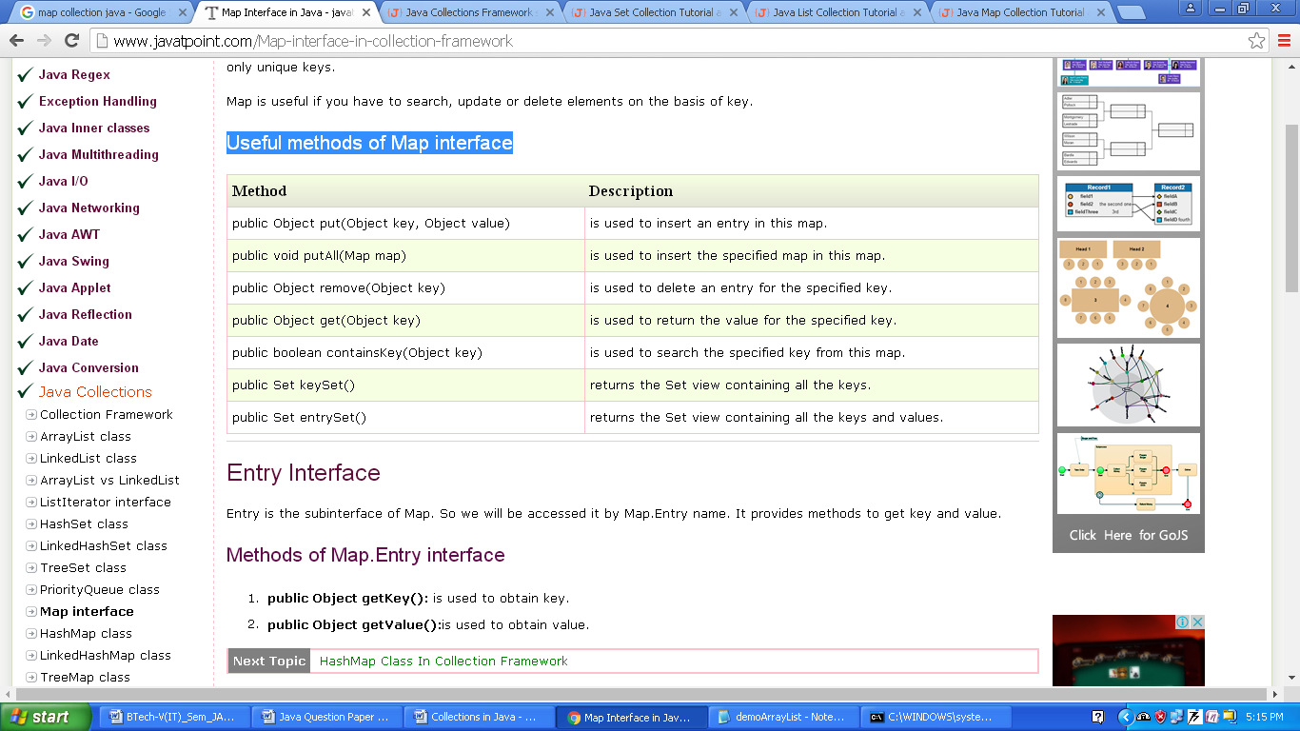

**Entry Interface**

Entry is the subinterface of Map. So we will be accessed it by Map.Entry name. It provides methods to get key and value.

**Methods of Map.Entry interface**

1. public Object getKey(): is used to obtain key.
2. public Object getValue():is used to obtain value.

**Java HashMap class**

A HashMap contains values based on the key. It implements the Map interface and extends AbstractMap class.

* It contains only unique elements.
* It may have one null key and multiple null values.
* It maintains no order.
* Hierarchy of HashMap class:

Example

import java.util.*;

class DemoHasMap{

public static void main(String args[]){

HashMap<Integer,String> hm=new HashMap<Integer,String>();

hm.put(100,"Amit");

hm.put(101,"Vijay");

hm.put(102,"Rahul");

for(Map.Entry m:hm.entrySet()){

System.out.println(m.getKey()+" "+m.getValue());

}

}

}

**Java LinkedHashMap class**

* A LinkedHashMap contains values based on the key. It implements the Map interface and extends HashMap class.
* It contains only unique elements.
* It may have one null key and multiple null values.
* It is same as HashMap instead maintains insertion order.

import java.util.*;

class DemoLinkedHashMap{

public static void main(String args[]){

LinkedHashMap<Integer,String> hm=new LinkedHashMap<Integer,String>();

hm.put(100,"Amit");

hm.put(101,"Vijay");

hm.put(102,"Rahul");

for(Map.Entry m:hm.entrySet()){

System.out.println(m.getKey()+" "+m.getValue());

}

}

}

**Java TreeMap class**

* A TreeMap contains values based on the key. It implements the NavigableMap interface and extends AbstractMap class.
* It contains only unique elements.
* It cannot have null key but can have multiple null values.
* It is same as HashMap instead maintains ascending order.

import java.util.*;

class DemoTreeMap {

public static void main(String args[]){

TreeMap<Integer,String> hm=new TreeMap<Integer,String>();

hm.put(100,"Amit");

hm.put(102,"Ravi");

hm.put(101,"Vijay");

hm.put(103,"Rahul");

for(Map.Entry m:hm.entrySet()){

System.out.println(m.getKey()+" "+m.getValue());

}

}

}

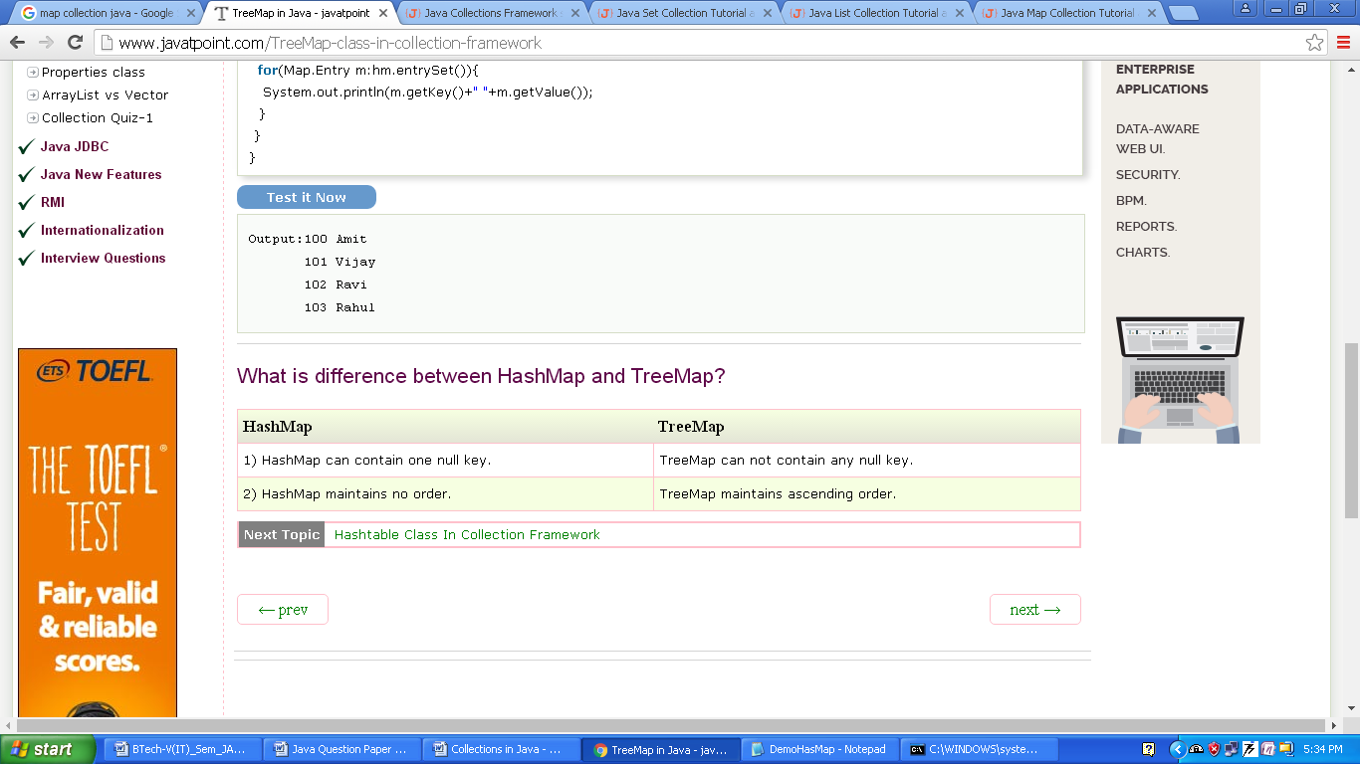What is difference between HashMap and TreeMap?